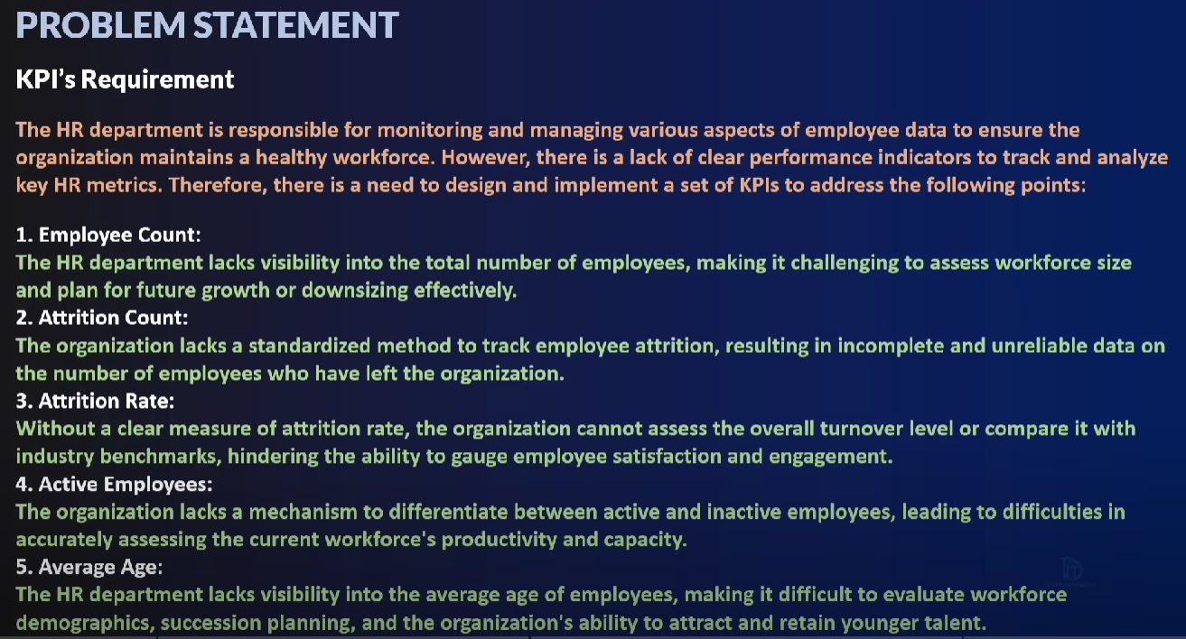

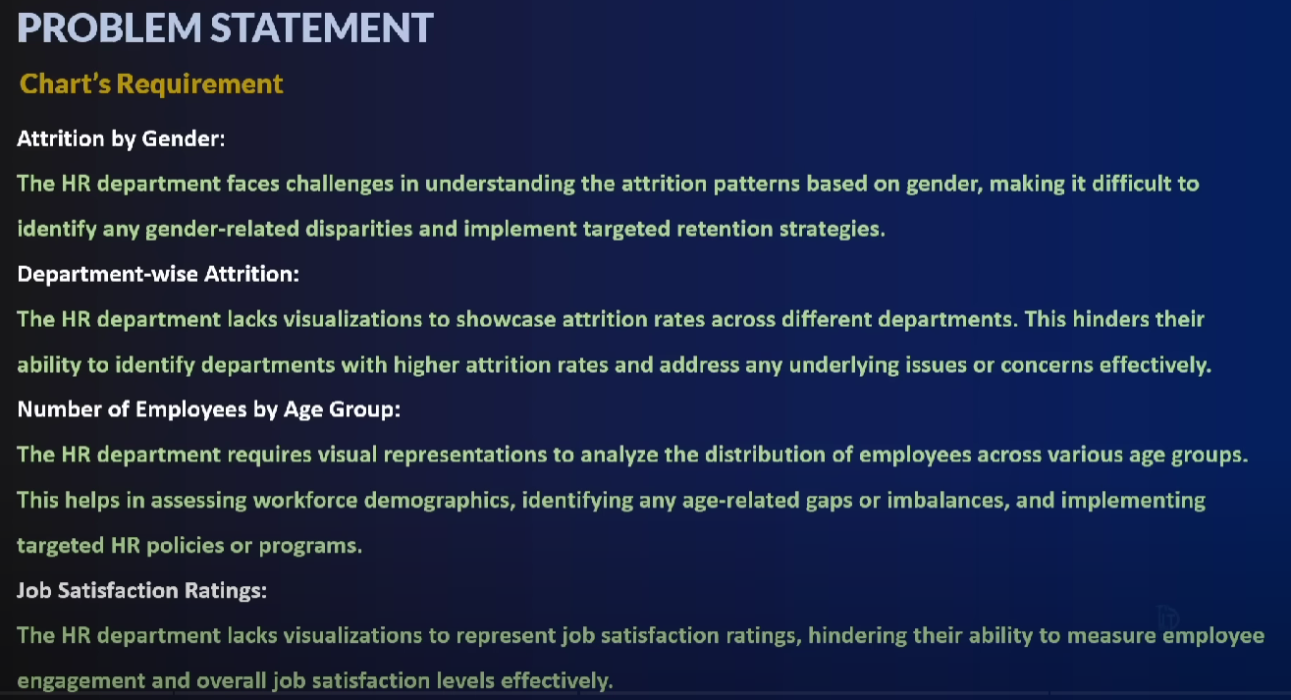

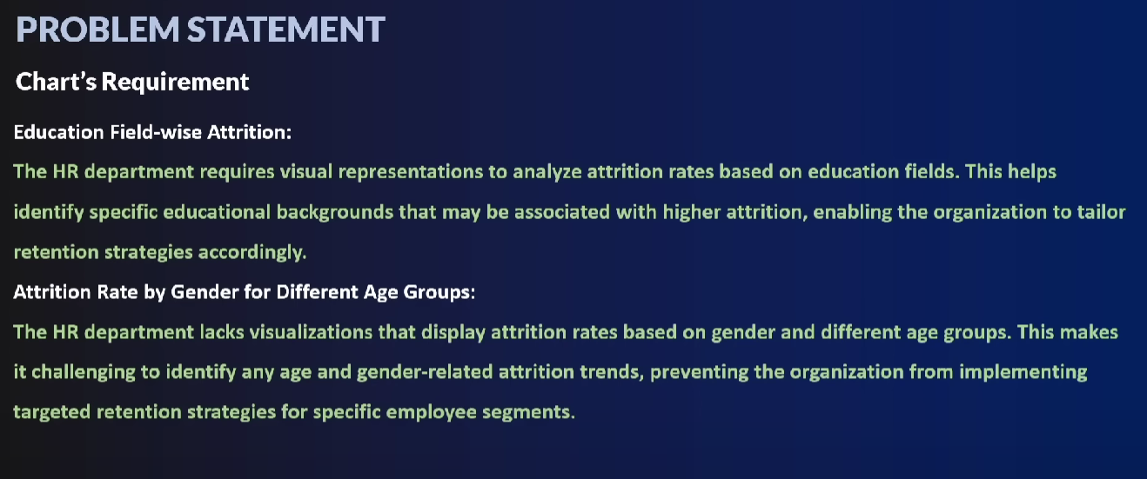

Measures and Dimensions:

* Measures are the numerical data which has summation symbol in front of them
* Dimensions are the categorical data

Key point to note while designing KPIs:

* What do you want to show in output? What is the ask? What is the scope of the project?
  + What are the reasons/factors of employee leaving the company
* KPIs supporting story

Tableau Report:

<https://public.tableau.com/app/profile/faraz.hussain6782/viz/HRAnalyticsDashboard_17004107966840/Dashboard?publish=yes>

SQL:

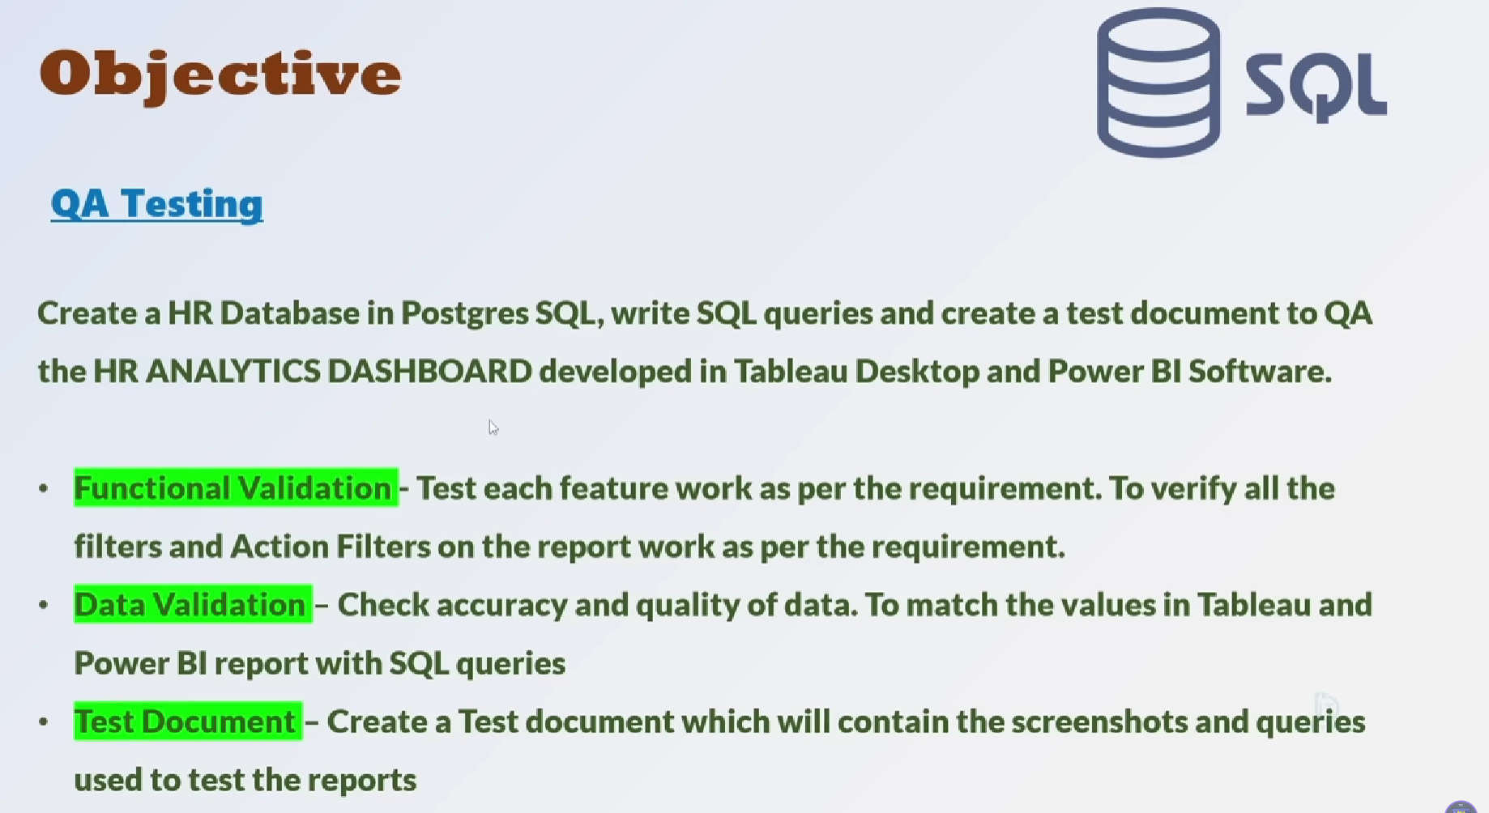

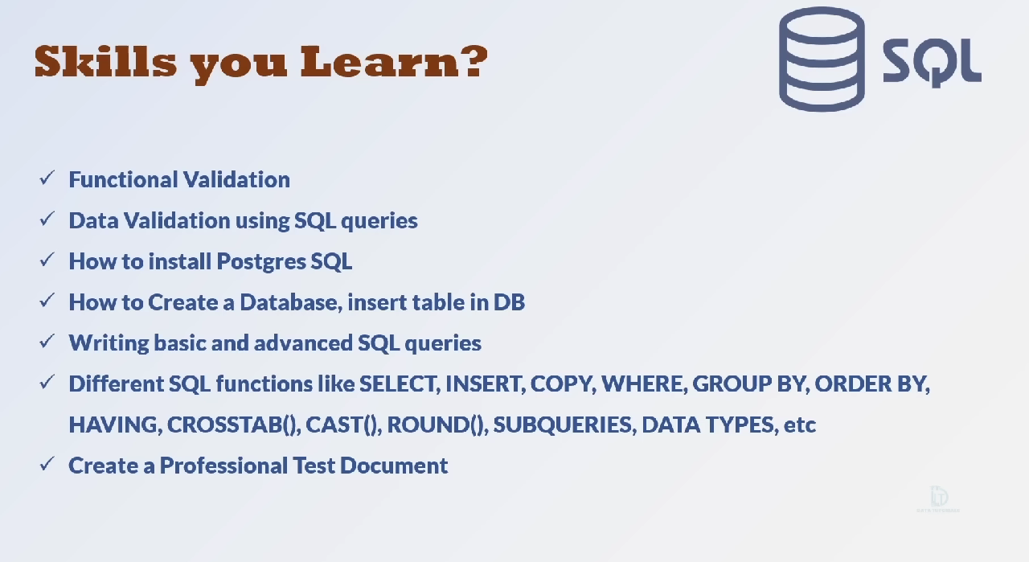

Functional Validation:

* Test all the filters in tableau/power bi dashboard is functioning